Decision tree is an algorithm that commonly used in data mining for classification by dividing data into branch-like segments, like a tree. To solve problems, do the calculation started from the top, which also called root node. Then work the way down and down through decision nodes. Eventually we will stop when we get to the point (leaf nodes), which determined by the lowest Gini impurity scores.
Here is an example in healthcare, where decision trees are helping on diagnose certain disease by given symptoms. In this case, we are going to predict whether or not a patient has heart disease using chest pain, good blood circulation and blocked artery status. First step, we need to decide which one would be the root node for the decision tree. We go through the relationship between each symptom and heart disease of all the patients and then got the result shown as below:
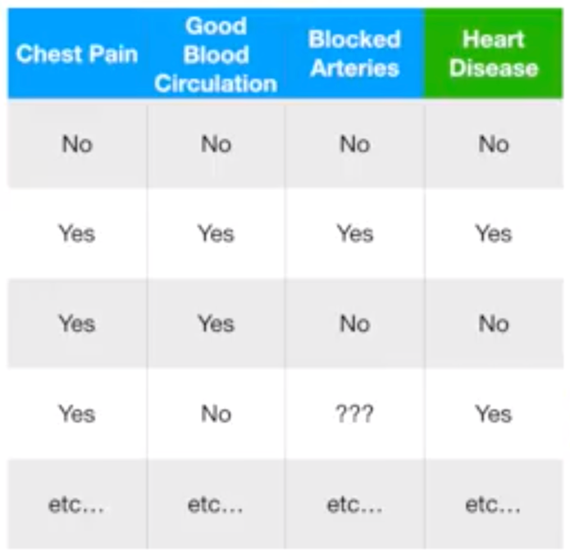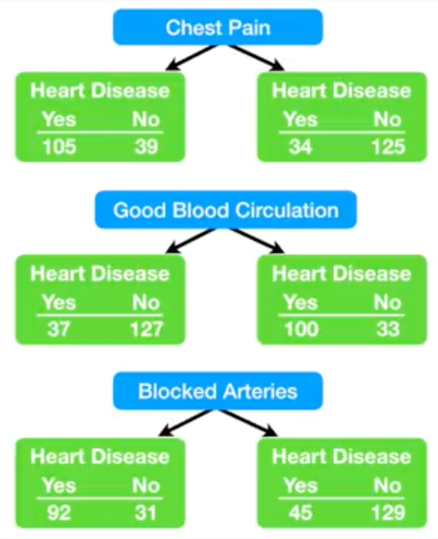
Then we calculate the Gini impurity scores of each symptom to measure impurity. The Gini impurity is calculated as: $G=\sum_{i=1}^{C}{p(i)×(1-p\left(i\right))}$ . The Gini impurity scores for Chest Pain, Good Blood Circulation and Blocked Arteries are 0.364, 0.360 and 0.381, respectively. Since the Good Blood Circulation has the lowest Gini impurity score, we are going to choose the Good Blood Circulation as the rood node of the decision tree. Then we do the exact same calculations to the rest of the branches and determine what symptoms to use. To decide whether the decision node would be the leaf node, simply compare the Gini impurity scores between before and after using a new symptom. Then always go with the lowest Gini impurity score. Here’s then decision tree we’ve got.
